**CSE3052 - INFORMATION SECURITY MANAGEMENT**

**DIGITAL ASSIGNMENT-2**

**ALOKAM NIKHITHA**

**19BCE2555**

**Experiment-3**

**TITLE:**

Firewall Configuration.

**AIM:**

To configure Firewall by allowing IP and denying ICMP.

**PROCEDURE:**

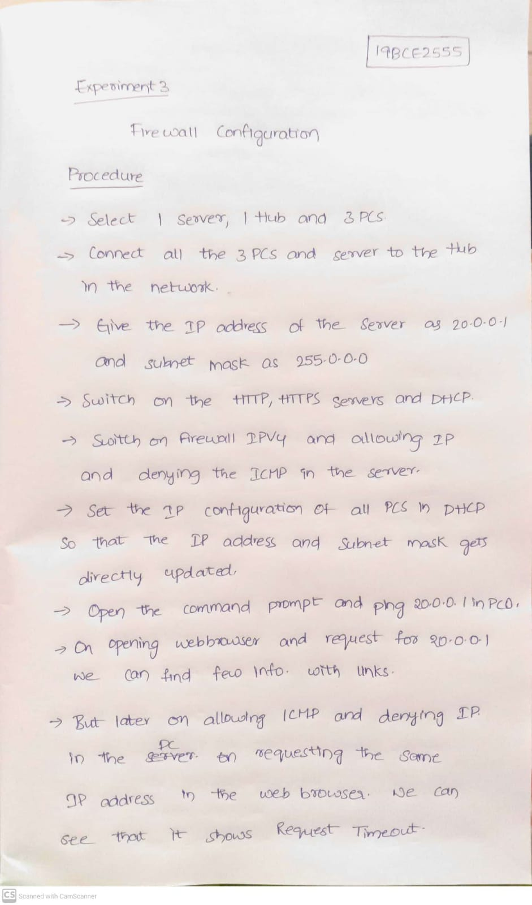

**TOPOLOGY** 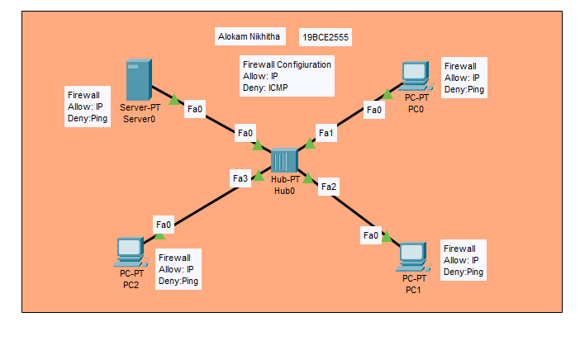

**Server IP Configuration:**

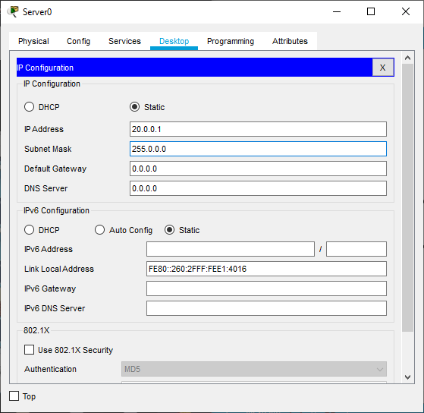

**Server Services:**

**Switching on HTTP, HTTPS and DHCP**

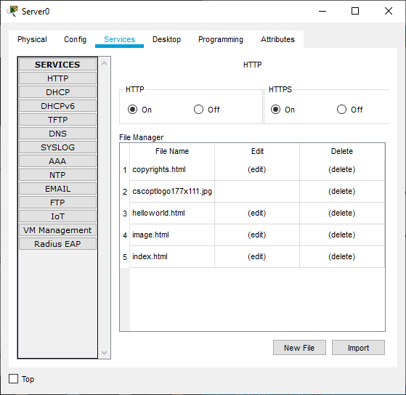 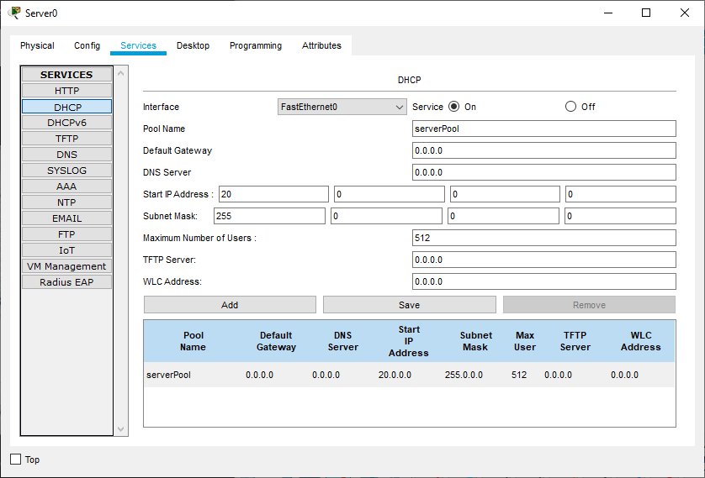

**Firewall Configuration :**  
Switching on Firewall IPv4 and denying the ICMP and allowing the IP

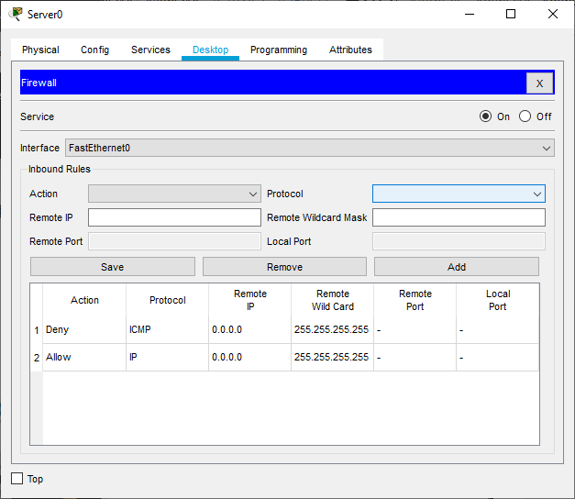

# **PC/ Computer Configuration:**

Ip Confiuration in DHCP .

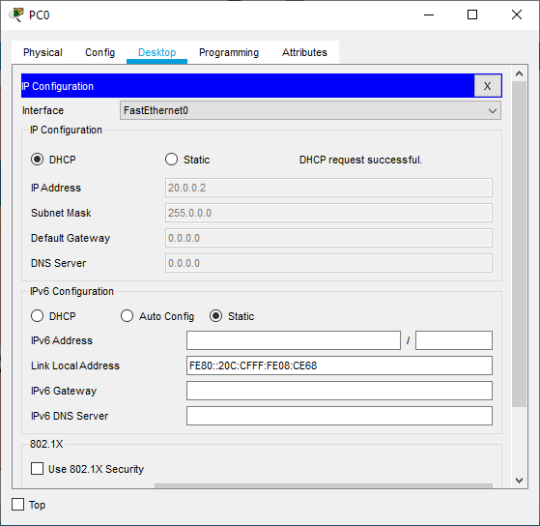

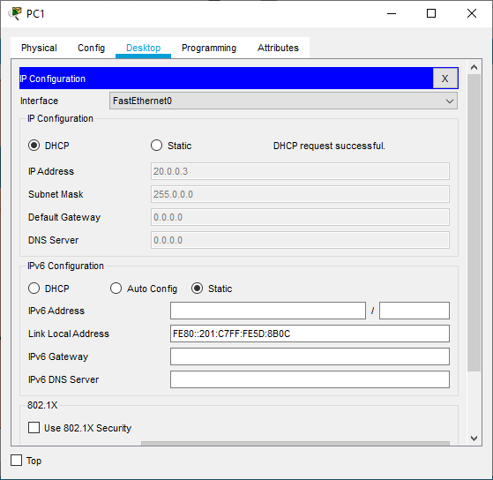

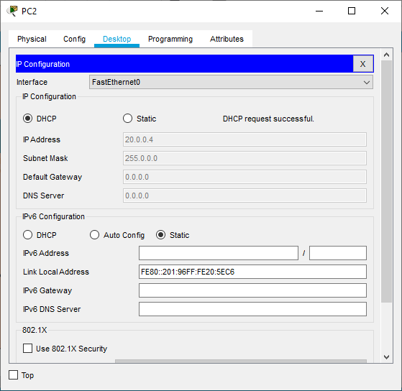

Command prompt (Pinging 20.0.0.1)

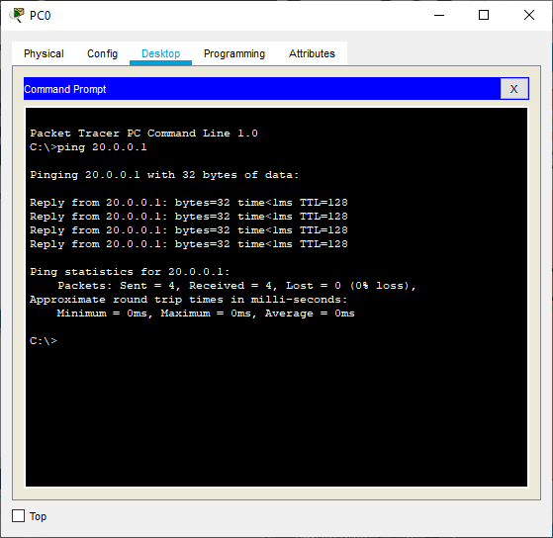

Request on Web browser

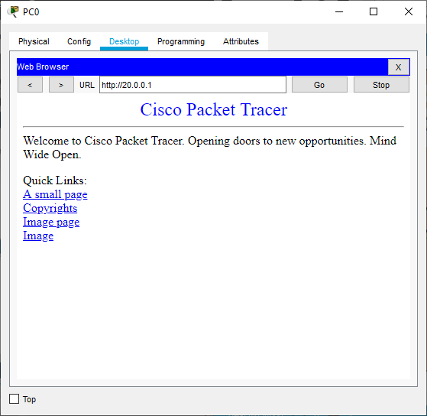

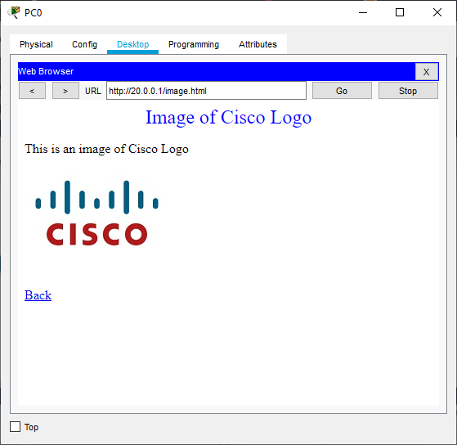

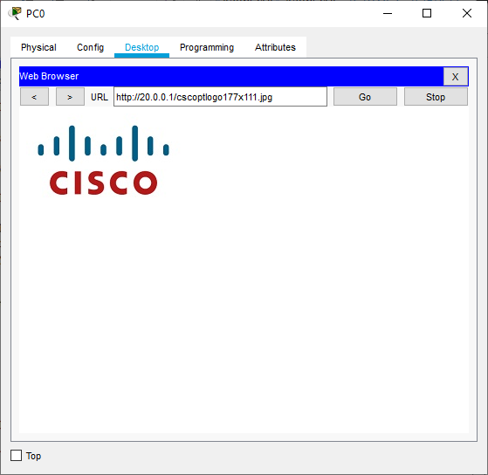

Changing the Firewall Configiuration (Allowing ICMP and denying IP)

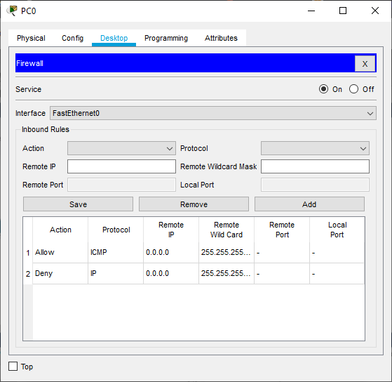

Command Prompt (pinging 20.0.0.1)

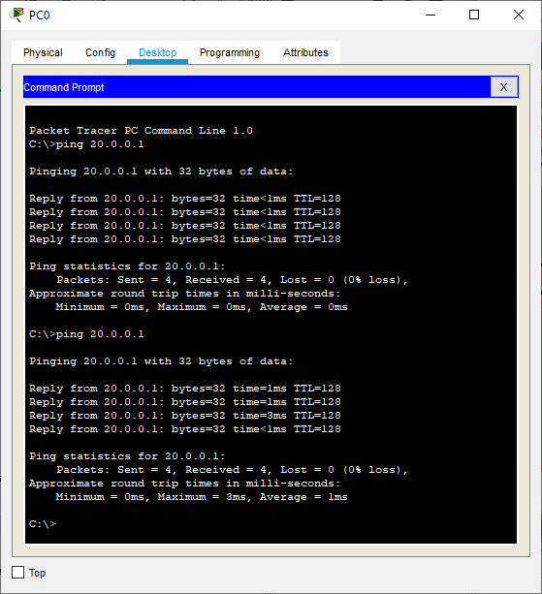

Request on Web browser

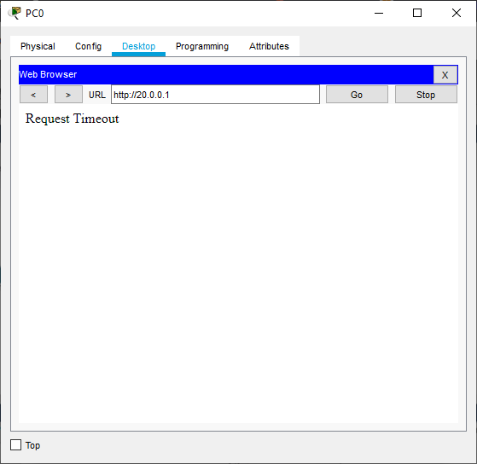

**Results**

**On Allowing IP and Denying ICMP**



**Image page:**



**Image:**



**A small page**

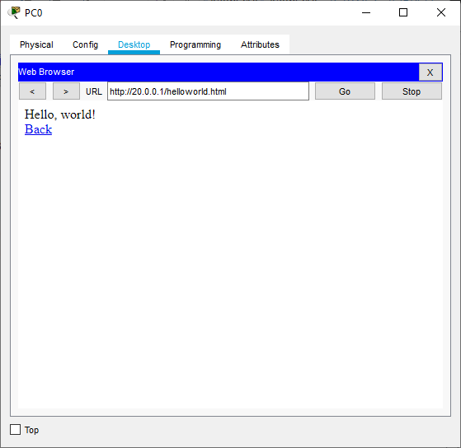

**License Agreement**

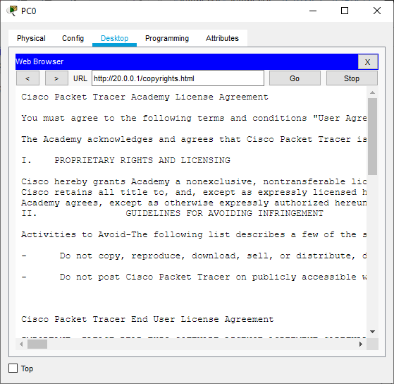

**On Allowing ICMP and Denying IP**



**Conclusion**

We can see that on allowing IP and Denying the ICMP .We can get the request for the given IP address on entering the IP address in Web browser of the PC. But on denying the IP address and allowing ICMP It shows that the Request time out on entering the IP address in web browser.

**Experiment-4**

**TITLE:**

Implementing Access Control Lists.

**AIM:**

To Implement Access Control Lists.

**PROCEDURE:**

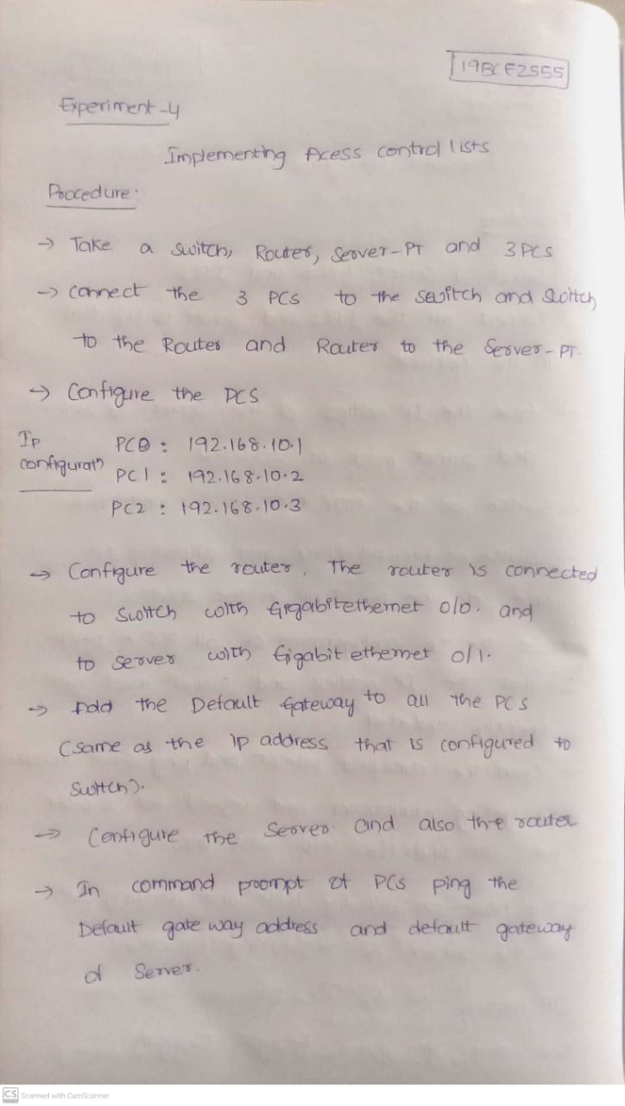

**TOPOLOGY**

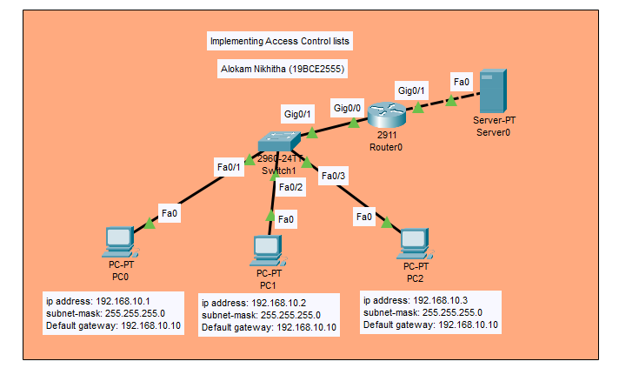

**PCs Configuration:**

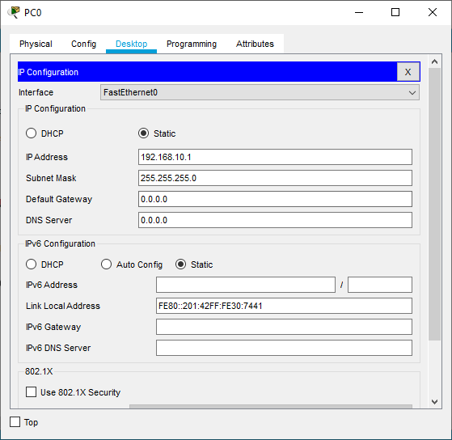

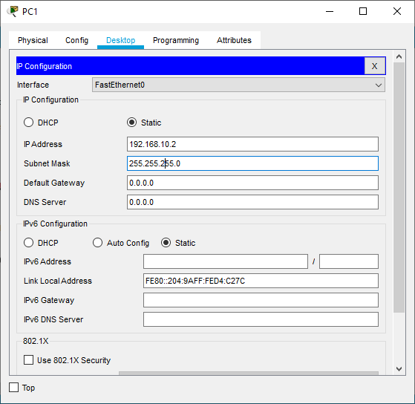

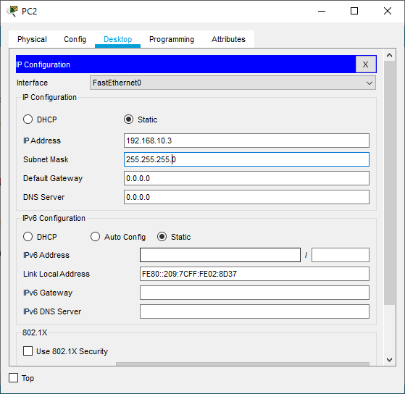

**Router Configuration:**

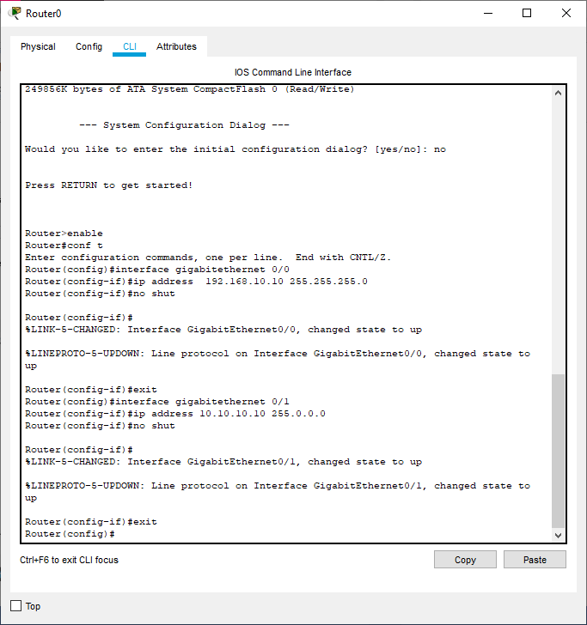

**Setting Default Gateway of the PCs**

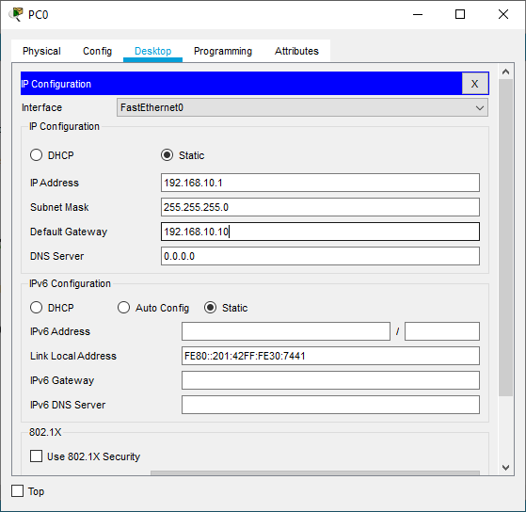

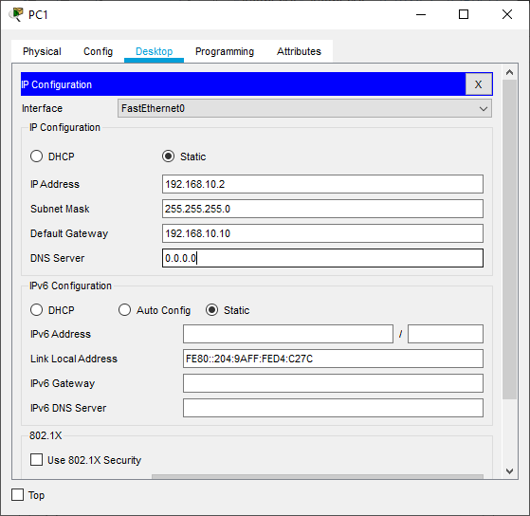

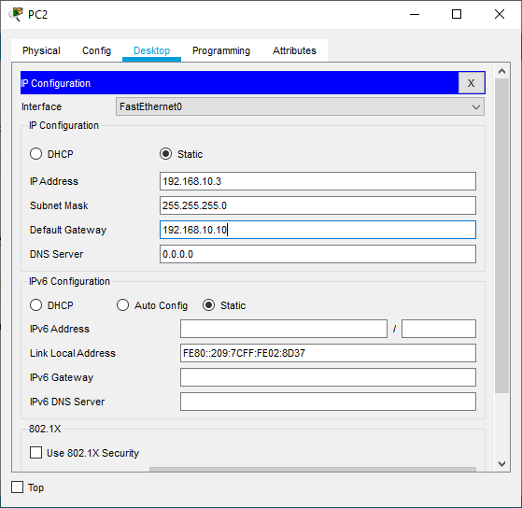

**Server IP Configuration:**

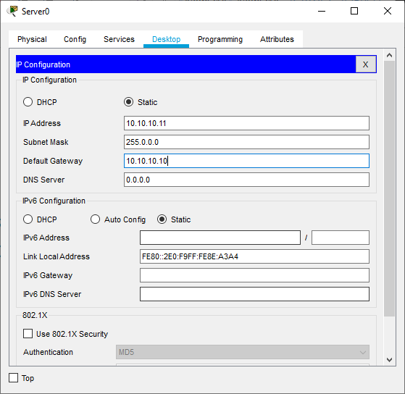

**Router Configuration**

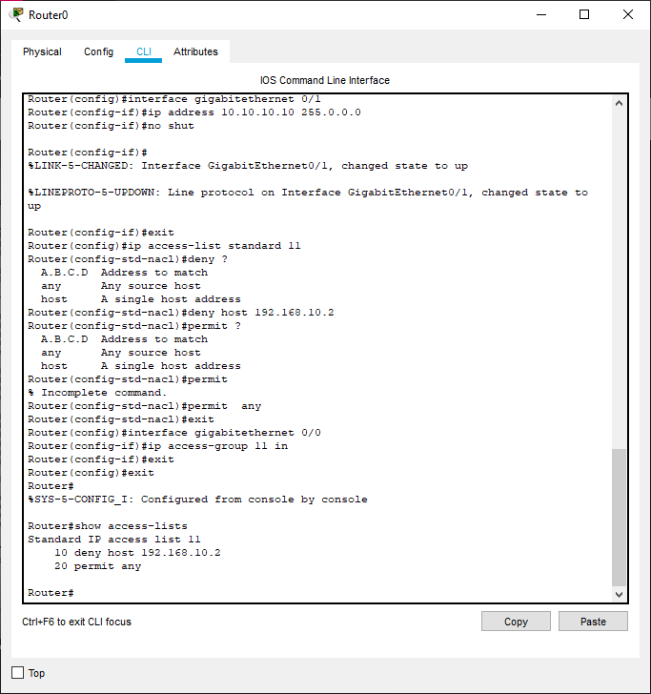

**Command Prompt of PCs:**

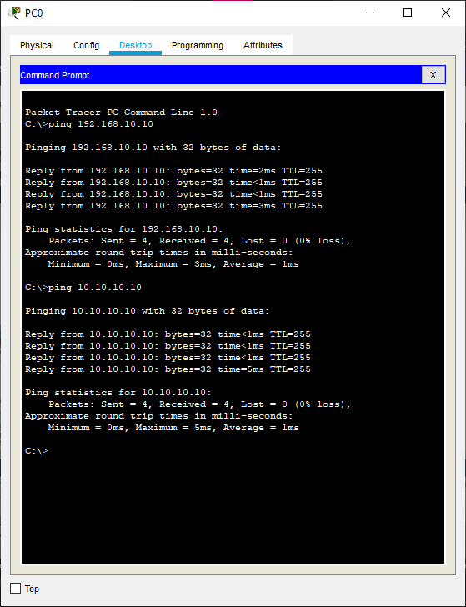

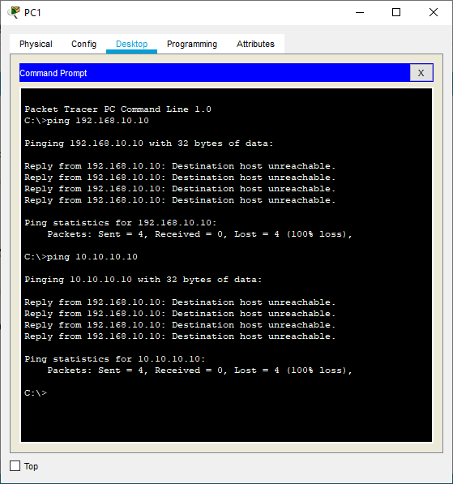 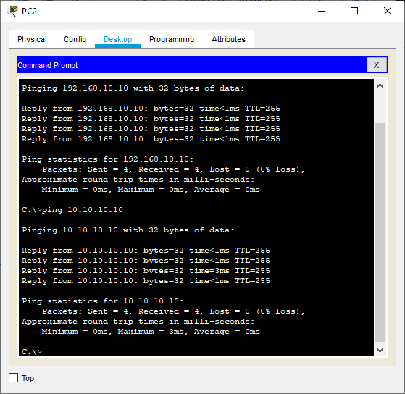

**Results**

**Command prompt of PC0:**



**Command prompt of PC1:**



**Command prompt of PC2:**



**Conclusion**

Here we can see that on pinging the Default gateway address We can find that in the PC0, PC2 . They reply is received from the pinged address . But where as in the PC1 . The Destination host is unreachable